**Meningococcal**

**Disease**

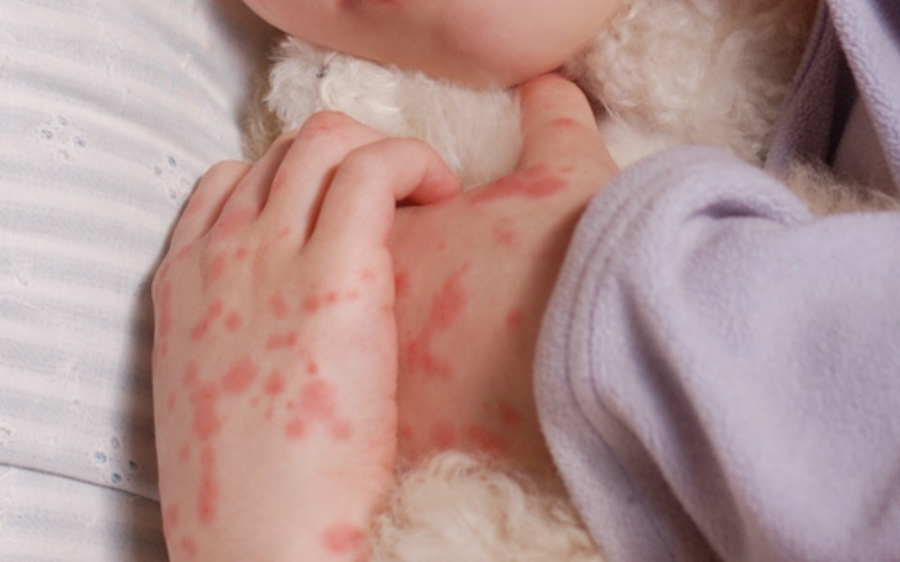

**What do you know about the different strains**

**& how do you protect your child?**